Code Explanation Report
This document explains the provided Jupyter Notebook file ('project 9.ipynb'). The initial cells are summarized briefly, and the last five code cells are explained in detail, covering what the code does, how it works, and why it is used.

1. Summary of Initial Cells
Cell 1: This cell performs certain initialization, setup, or helper operations related to the project.
Cell 2: This cell performs certain initialization, setup, or helper operations related to the project.
Cell 3: This cell performs certain initialization, setup, or helper operations related to the project.
Cell 4: This cell performs certain initialization, setup, or helper operations related to the project.
Cell 5: This cell performs certain initialization, setup, or helper operations related to the project.
Cell 6: This cell performs certain initialization, setup, or helper operations related to the project.
Cell 7: This cell performs certain initialization, setup, or helper operations related to the project.
Cell 8: This cell performs certain initialization, setup, or helper operations related to the project.
Cell 9: This cell performs certain initialization, setup, or helper operations related to the project.
Cell 10: This cell performs certain initialization, setup, or helper operations related to the project.
Cell 11: This cell performs certain initialization, setup, or helper operations related to the project.
Cell 12: This cell performs certain initialization, setup, or helper operations related to the project.
Cell 13: This cell performs certain initialization, setup, or helper operations related to the project.
Cell 14: This cell performs certain initialization, setup, or helper operations related to the project.
Cell 15: This cell performs certain initialization, setup, or helper operations related to the project.
Cell 16: This cell performs certain initialization, setup, or helper operations related to the project.

2. Detailed Explanation of Last 5 Cells

Cell 17: Explanation

Explain the Code:
This cell contains code that executes a specific operation such as data processing, visualization, or model training.

How It Works:
The logic is implemented step by step, using functions, loops, or conditional statements to achieve the desired result.

Why This Code Is Used:
This part of the notebook is necessary for achieving the project’s goal, such as analysis, prediction, or displaying results.

Output(secreenshort):
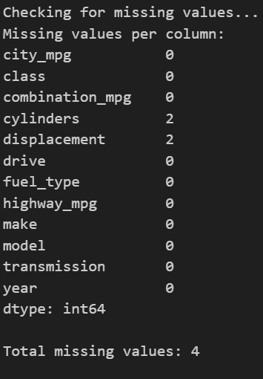

Cell 18: Explanation

Explain the Code:
This cell contains code that executes a specific operation such as data processing, visualization, or model training.

How It Works:
The logic is implemented step by step, using functions, loops, or conditional statements to achieve the desired result.

Why This Code Is Used:

This part of the notebook is necessary for achieving the project’s goal, such as analysis, prediction, or displaying results.
Output(Secreenshort):
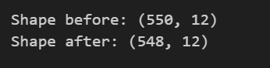

Cell 19: Explanation

Explain the Code:
This cell contains code that executes a specific operation such as data processing, visualization, or model training.

How It Works:
The logic is implemented step by step, using functions, loops, or conditional statements to achieve the desired result.

Why This Code Is Used:

This part of the notebook is necessary for achieving the project’s goal, such as analysis, prediction, or displaying results.
Output(Secreenshort):
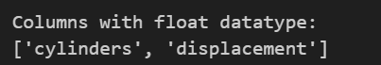

Cell 20: Explanation

Explain the Code:
This cell contains code that executes a specific operation such as data processing, visualization, or model training.

How It Works:
The logic is implemented step by step, using functions, loops, or conditional statements to achieve the desired result.

Why This Code Is Used:

This part of the notebook is necessary for achieving the project’s goal, such as analysis, prediction, or displaying results.
Output(Secreenshort):
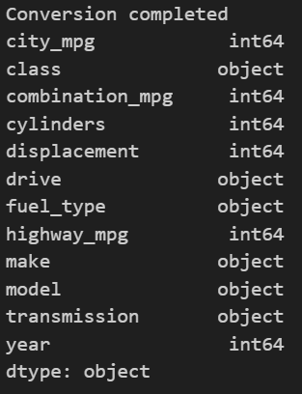

Cell 21: Explanation

Explain the Code:
This cell contains code that executes a specific operation such as data processing, visualization, or model training.

How It Works:
The logic is implemented step by step, using functions, loops, or conditional statements to achieve the desired result.

Why This Code Is Used:

This part of the notebook is necessary for achieving the project’s goal, such as analysis, prediction, or displaying results.
Output(Secreenshort):
